Theresa Davies 6 Windsor Gdns, Bishop’s Stortford, Herts CM23 4PQ.
07854 777461 01279 501134 E: tdaviestutors@gmail.com
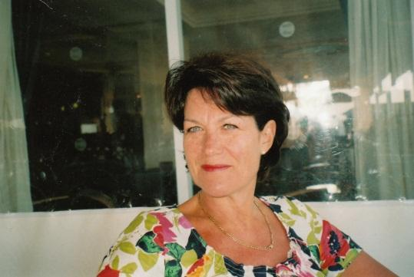
Before the Assessment: Please download the Background Questionnaire from my website and return this as a word doc or post. I will then request a deposit. The School Questionnaire can be returned at a later date.The deposit is non-refundable. As soon as the deposit is received I can give you a date. The assessment will take up a whole midweek morning.
The Assessment is done at my home (Bishop’s Stortford) in my large, heated, socially distanced Conservatory at the back of the house. When you arrive I will bring you around the side entrance so you do not have to enter the house.
Please fill in the Background Questionnaire as well as you can, as I need this to prepare the session. Please ensure I receive the School Questionnaire and any additional relevant information such as an IEP/Support Plan before the Assessment.
Please make sure your child has some breakfast before they come, it will help them to concentrate. Please bring a drink, snacks, your child’s pencil case, glasses and overlay if they have them. When you arrive we will have a brief chat to put your child at ease.
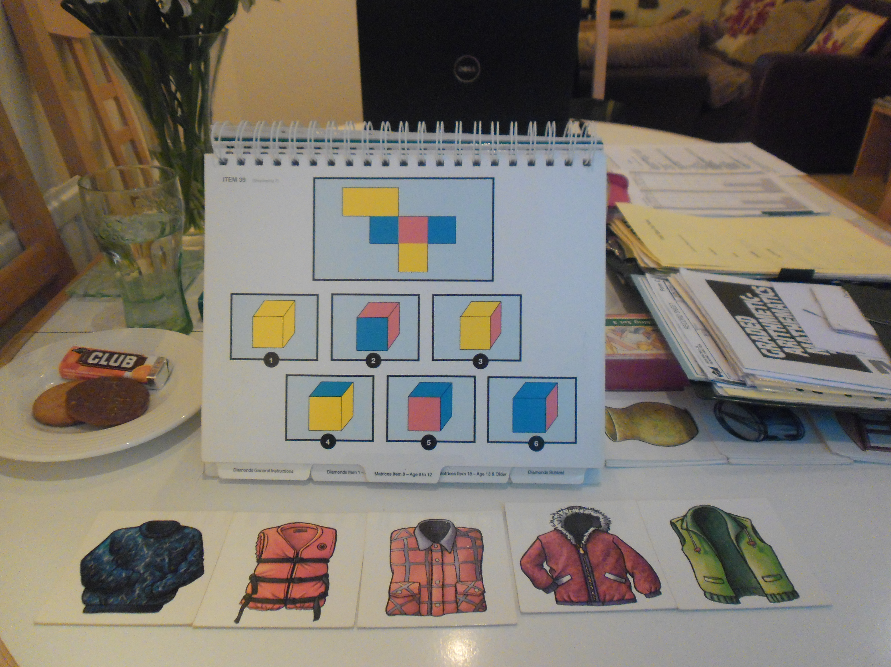
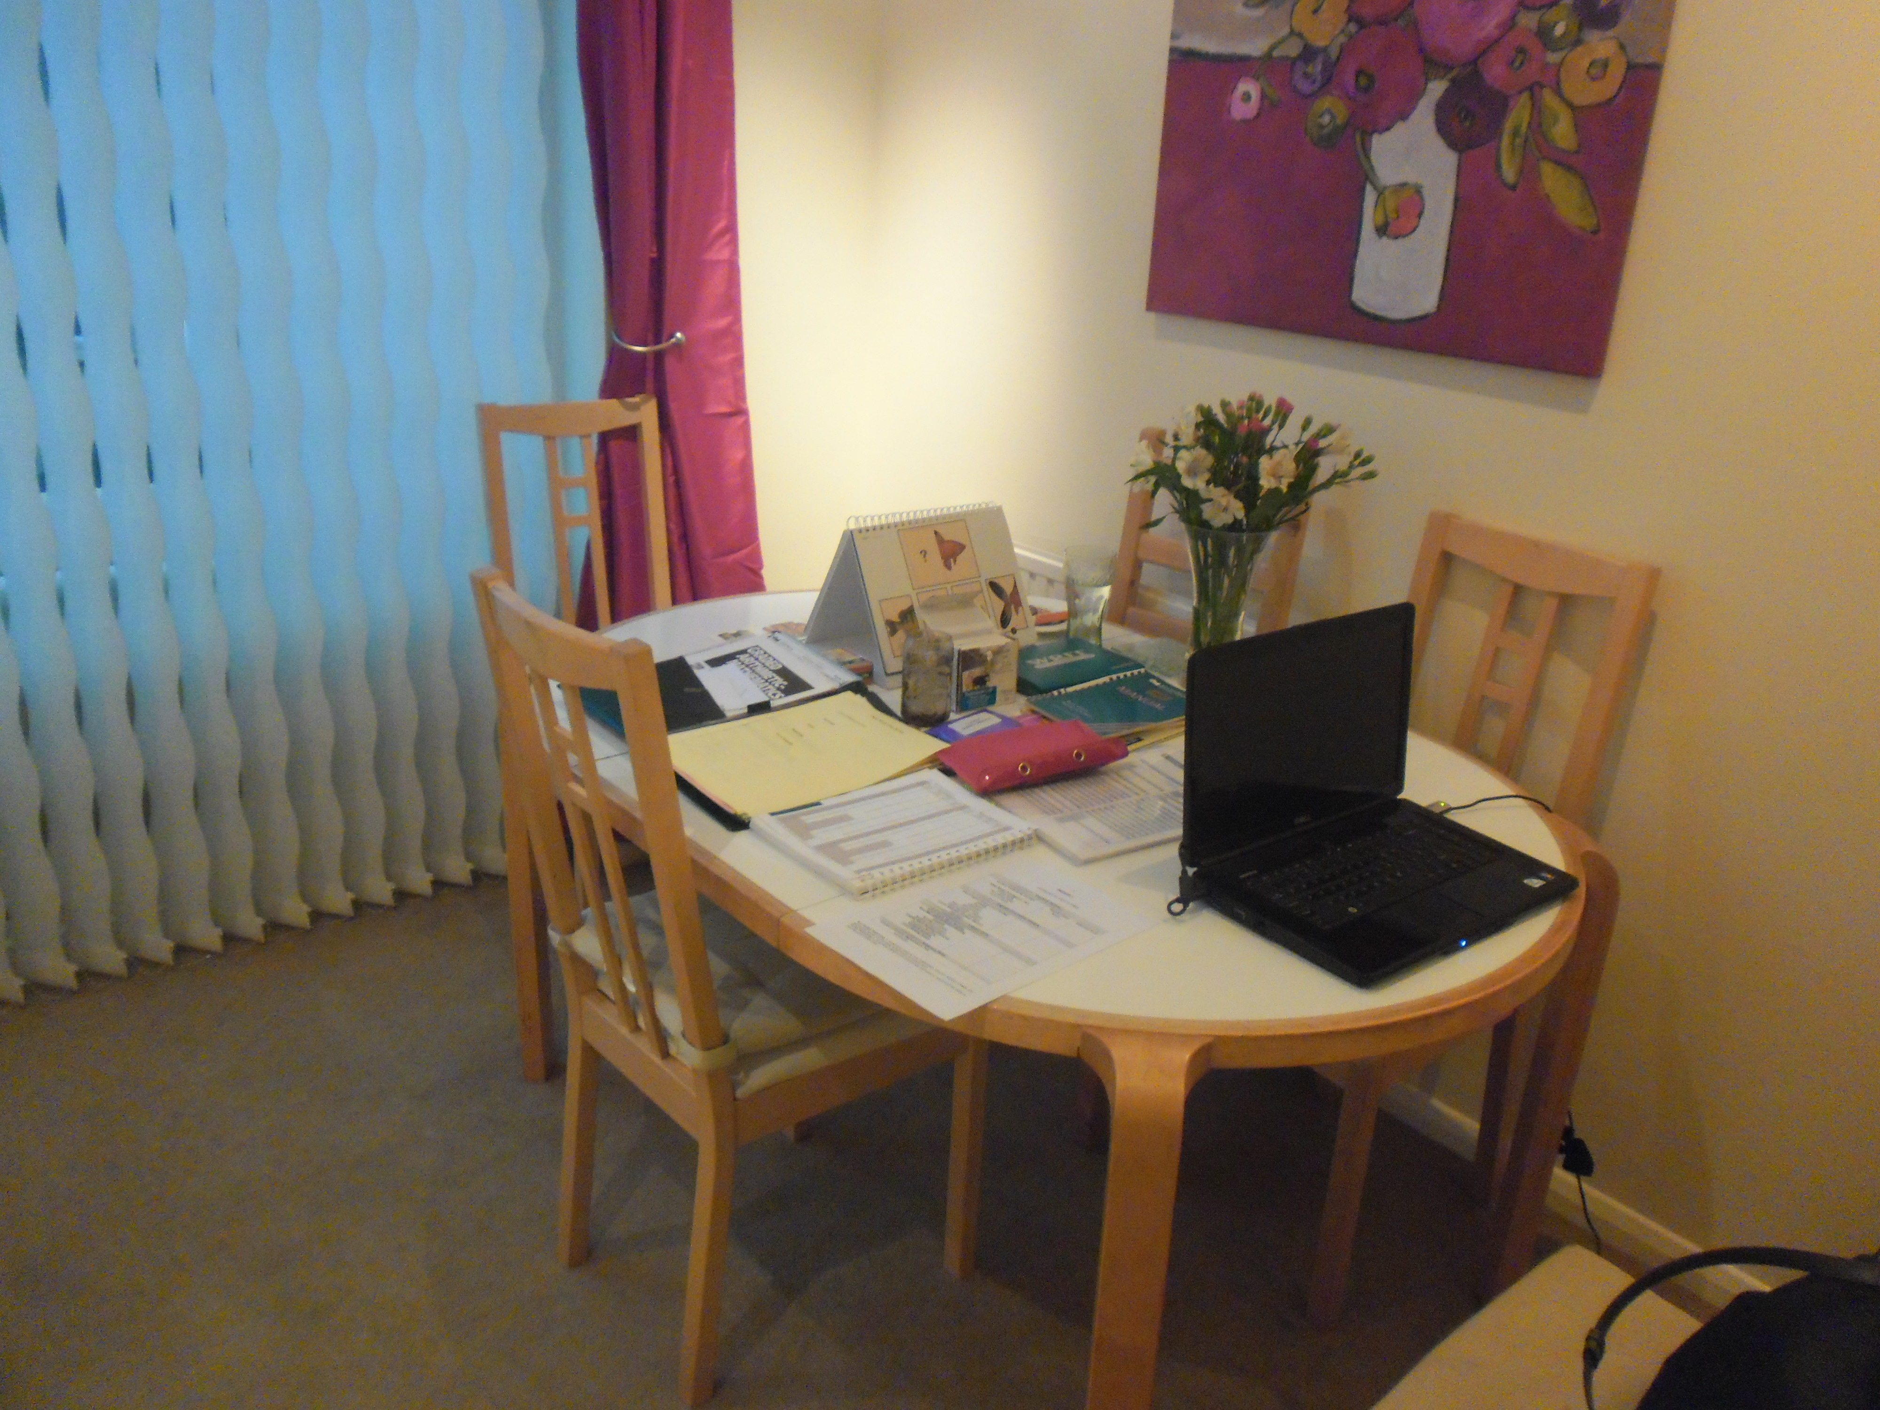

We will do a variety of exercises during the assessment; children find these interesting and even the most nervous children soon settle into it. The assessment will take approx 2 hours. The detailed Diagnostic Report with Recommendations will be e-mailed 1 week after the Assessment. You will not be able to stay during the assessment. You can pop down to the nearby Tesco/ Costa Coffee. The town centre is a short drive away. Alternatively you can park and wait on our drive. I will feed back my observations and some test results when you return to collect your child. Have a safe journey and I look forward to meeting you.

